Skyhook Launch Spine
Staged Ascent White Paper Proof of Concept
Document Type | Proof-of-concept white paper
Concept Thesis | Replace the lower portion of a full space elevator with a powered atmospheric launch spine, then hand off to an upper-atmosphere orbital ascent system.
Primary Integration | Vertical megastructure + split rail transit + upper transition hub + orbital interface
Status | High-level staged ascent architecture draft
Abstract
Skyhook Launch Spine is a staged ascent concept that reduces the structural and atmospheric burden of a full ground-to-orbit elevator by replacing the lower portion of the climb with a megastructure launch spine. Payloads ascend through dense atmosphere on a powered vertical rail system, reach an upper-atmosphere transition hub, and then transfer to an orbital ascent vehicle or rendezvous architecture for final insertion. The system uses a split-rail logic in which the main spine carries the structural burden, the electrical rail provides lift power and transport authority, and the plasma rail serves as an active support layer for stabilization, signaling, and environmental control. The result is a more credible corridor-style ascent system than a single uninterrupted tether stretching from ground to orbit.
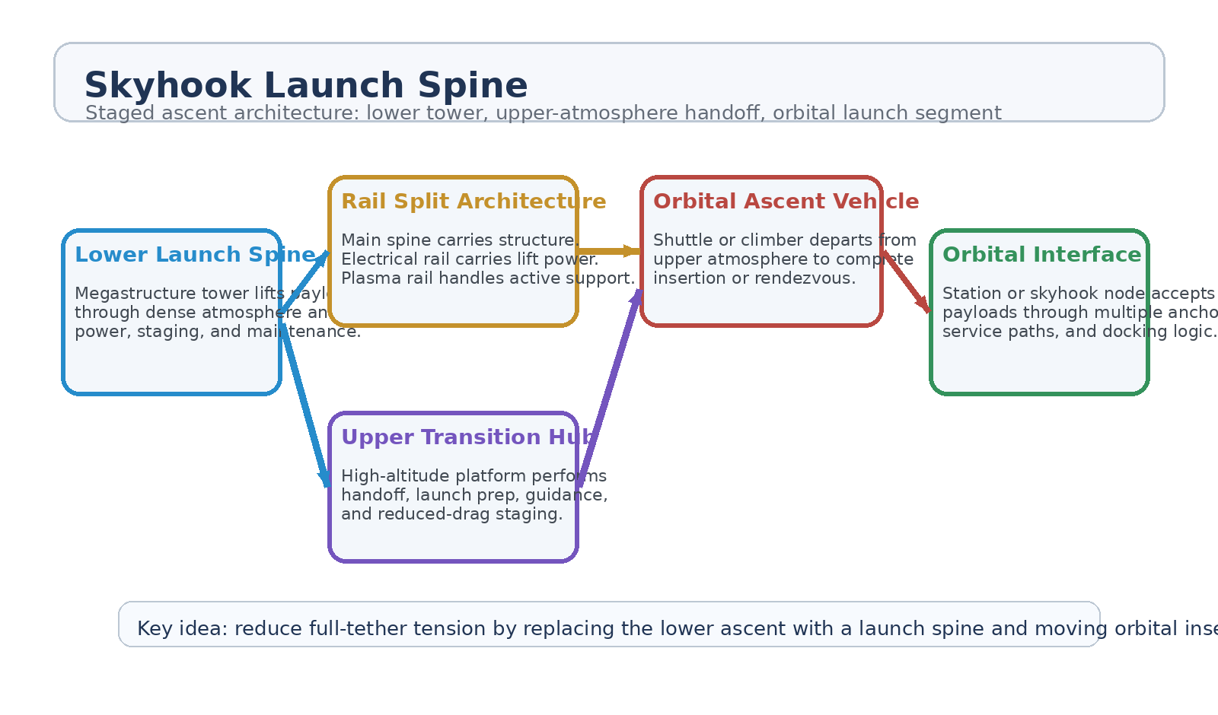
Figure 1. Skyhook Launch Spine architecture with lower launch spine, split rails, transition hub, and orbital handoff.
1. Concept Thesis
The core insight is that a classic space elevator demands one continuous structure to survive too many jobs at once: structural tension, atmospheric exposure, power delivery, transit control, and orbital handoff. Skyhook Launch Spine breaks that burden apart. The lower atmosphere is handled by architecture and rail power, while orbital insertion is handled later by a separate upper-stage system.
This turns the problem from a single impossible tether into a staged corridor: tower, transition, ascent, docking.
2. Why the Split Helps
• Reduces the need for one continuous ground-to-orbit tension structure.
• Moves the earliest ascent through dense atmosphere into a controlled megastructure environment.
• Cuts weather and drag exposure for the orbital insertion vehicle.
• Allows maintenance, staging, and inspection to occur inside the lower launch spine instead of on a naked tether.
• Improves fault isolation by separating structure, power, and active support into different paths.
3. Split Rail Architecture
Layer | Subsystem | Primary Function | Why It Exists
L1 | Main Spine | Primary structural and alignment backbone for the vertical ascent corridor. | Carries the burden instead of a full orbital tether.
L2 | Electrical Rail | Provides lift power, control authority, and guideway logic for climbers or launch carriages. | Makes ascent a powered rail problem rather than passive climbing alone.
L3 | Plasma Rail | Provides active support for signaling, thermal/environmental conditioning, and stabilization assist. | Acts as the corridor support layer, not the main lifter.
L4 | Transition Hub | Performs payload handoff, launch staging, docking prep, and guidance transfer. | Separates atmospheric ascent from orbital insertion.
L5 | Orbital Interface | Receives payloads through docking, rendezvous, or skyhook-style capture logic. | Completes the last step without one continuous full-length elevator.

3.1 Lower Launch Spine
The lower launch spine is best understood as a vertical transport megastructure. It behaves less like a cable and more like an engineered ascent corridor: protected guideway, maintenance access, segmented power feed, and controlled weather-facing infrastructure. That makes the lower part of ascent a civil/industrial megastructure challenge rather than a pure materials miracle.
3.2 Upper Transition Hub
The transition hub sits high enough to reduce atmospheric drag and environmental turbulence for the orbital stage. This is where the corridor shifts from tower logic to launch logic. Payloads, shuttles, or ascent vehicles can be serviced, aligned, and accelerated under much cleaner conditions than a sea-level launch pad.
3.3 Orbital Handoff
The final leg can be completed by a shuttle, rendezvous vehicle, or skyhook-compatible orbital transfer system. The important point is that the upper-stage vehicle no longer carries the full penalty of ground launch. The lower launch spine has already absorbed part of the climb, part of the staging burden, and part of the atmospheric punishment.
4. Use Cases
• High-frequency cargo ascent to orbital stations.
• Passenger transfer to upper-atmosphere launch hubs before final orbital insertion.
• Fuel, water, or industrial mass transfer where repeated launch cadence matters more than one-shot rocket performance.
• Staged launch architecture for larger orbital construction programs.
• Hybrid tower-to-skyhook corridors where orbiting infrastructure is already present.
5. Benefits Compared with a Full Space Elevator
• Lower structural tension demand than a single uninterrupted ground-to-orbit system.
• Clear separation of atmospheric ascent and orbital insertion.
• More realistic maintenance and inspection access.
• Better opportunity for phased buildout: tower first, hub second, orbital handoff third.
• Improved system resilience through multiple service paths and multiple connection points at the orbital end.
6. Primary Challenges
The staged architecture is stronger, but still brutal. It does not erase the cost or difficulty of mega-scale ascent infrastructure.
• Extreme tower materials and dynamic load management.
• Wind, resonance, and oscillation control across a very tall structure.
• Safe high-altitude transition and shuttle handoff.
• Massive capital cost and construction logistics.
• Orbital synchronization and docking complexity at the upper end.
7. Proof-of-Concept Build Path
Phase | Goal | Bench / Program Activity | Success Signal
P1 | Transit spine model | Demonstrate split-rail lower ascent logic in a vertical guideway mockup. | Stable guided lift behavior.
P2 | Segmented power architecture | Validate main spine, electrical rail, and active support rail separation under simulated load. | No single-path dependency.
P3 | Transition hub logic | Model the high-altitude handoff between vertical ascent carriage and orbital-stage vehicle. | Clean service and guidance transfer.
P4 | Dynamic stability review | Analyze resonance, weather loading, and fault isolation for the lower megastructure. | Acceptable stability envelope.
P5 | Orbital interface simulation | Test docking/rendezvous workflow at the station-side multi-anchor interface. | Repeatable end-to-end corridor logic.

8. Boundaries and Realism
Skyhook Launch Spine is not a claim that an ordinary skyscraper can simply become a cheap path to orbit. It is a staged ascent architecture intended to make the full space-elevator problem less singular and more modular. The lower section is an atmospheric launch spine. The upper section is an insertion and rendezvous problem. That division is what makes the concept more coherent than a one-piece elevator fantasy.
9. Conclusion
Skyhook Launch Spine turns the idea of a sky elevator into something more structurally honest: a tower for the atmosphere, a hub for the handoff, and a separate orbital ascent segment for the final climb. The rail system is split so each path does a different job. The main spine carries the burden. The electrical rail carries the motion. The plasma rail keeps the corridor alive.
That makes the concept suitable as a white paper PoC for staged ascent infrastructure rather than as a claim that one cable solves Earth-to-orbit transit by itself.
Working one-line doctrine: The spine carries the burden, the rail carries the motion, and the upper handoff keeps orbit honest.

